**Surveilia Screen shots**

Github: [Surveilia (github.com)](https://github.com/Surveilia)

Wix site: [Home | Surveilia (wixsite.com)](https://surveilia.wixsite.com/surveilia)

**Documentation**

Documentation was done using Github & Excell. Github contains most of the project contents, except for flight systems such as BetaFlight & Mission Planner.

The *Documentation* repository on Github contains much of our other course work from English. It contains the final report & user manual, and the progress report. There also is a document of our scope.

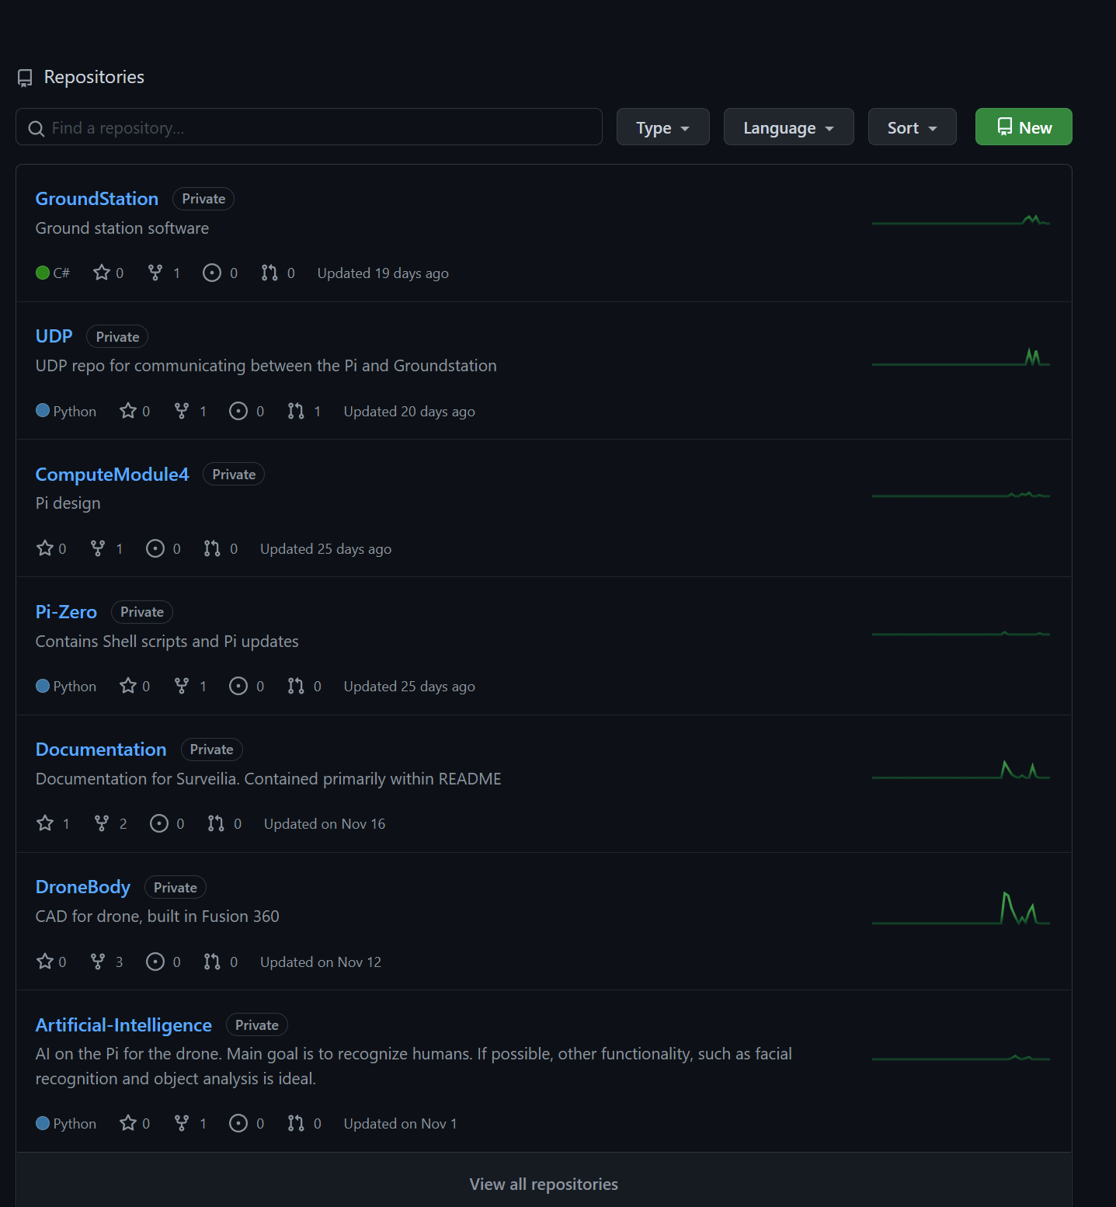

Figure 1 Organization

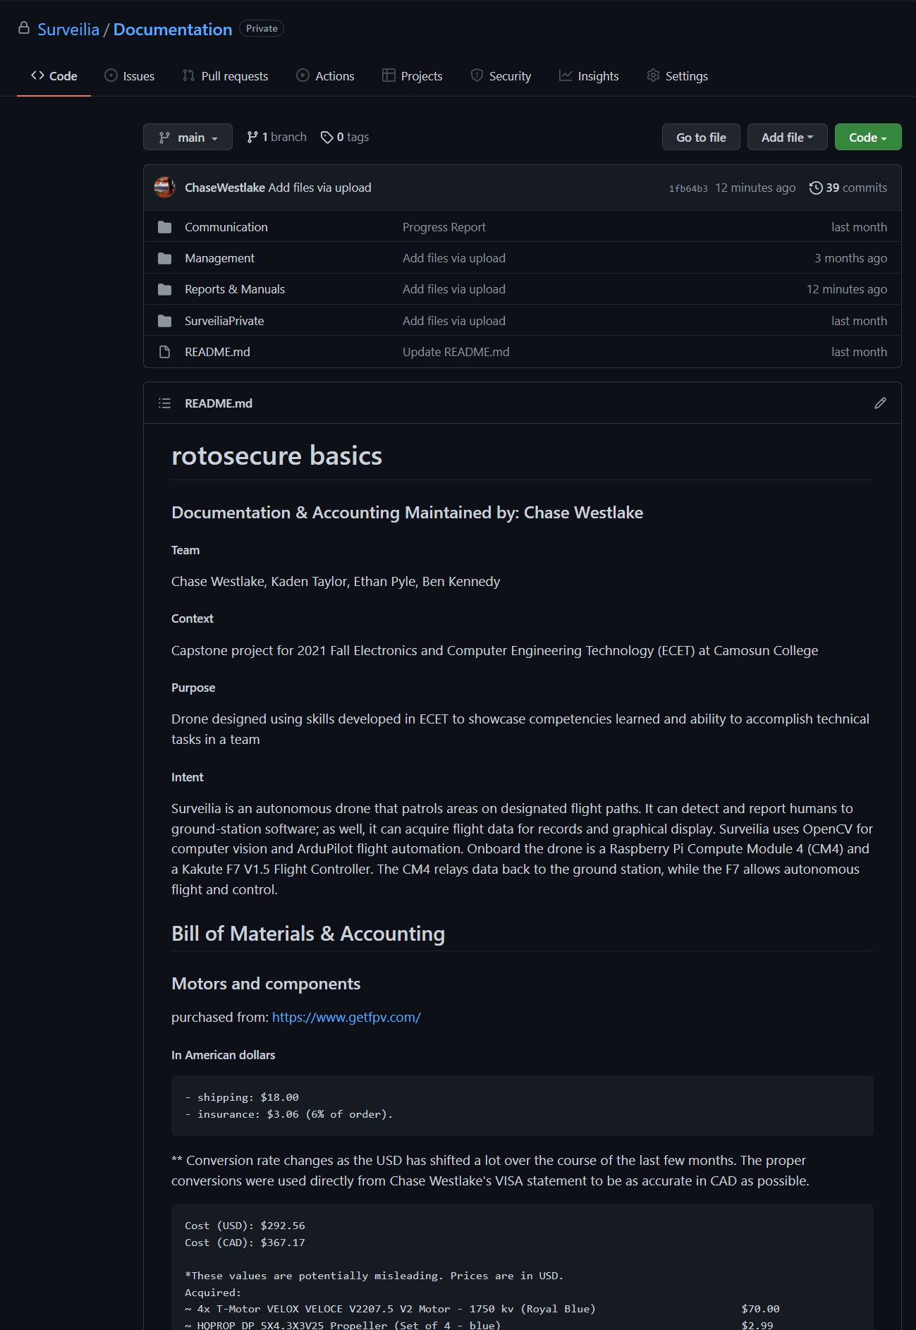

Figure Documentation README contains accounting information and links to resources used in the project. The files contain documentation used throughout some of the courses that were considered relevant to Surveilia.

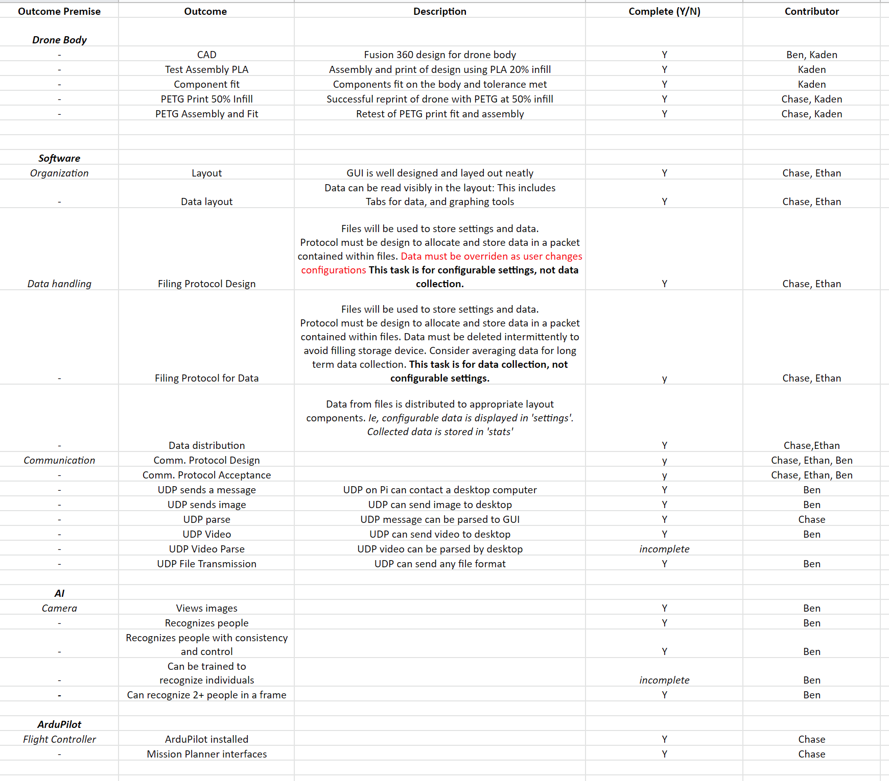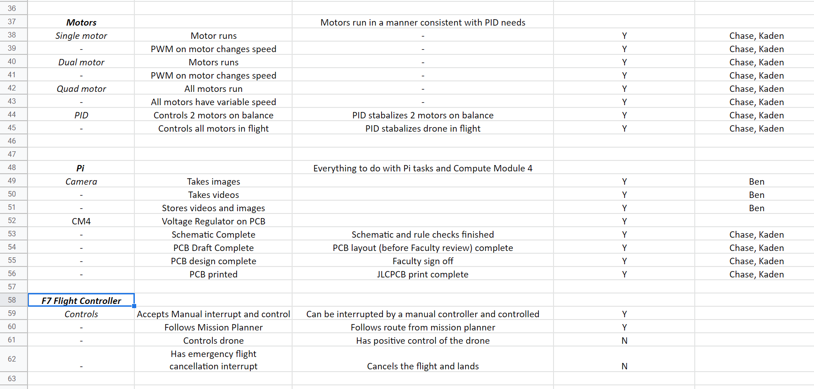

Figure 3 Tasks and achievements

**Ground Station**

[Surveilia/GroundStation: Ground station software (github.com)](https://github.com/Surveilia/GroundStation). Please view the ground station code at this link. There is far too much code to post. The ground station was for data collection & display. Some features were added to give a more complete feel and appearance.

The ground station has bugs, however it performs it’s main function (displaying images from the human recognition) perfectly.

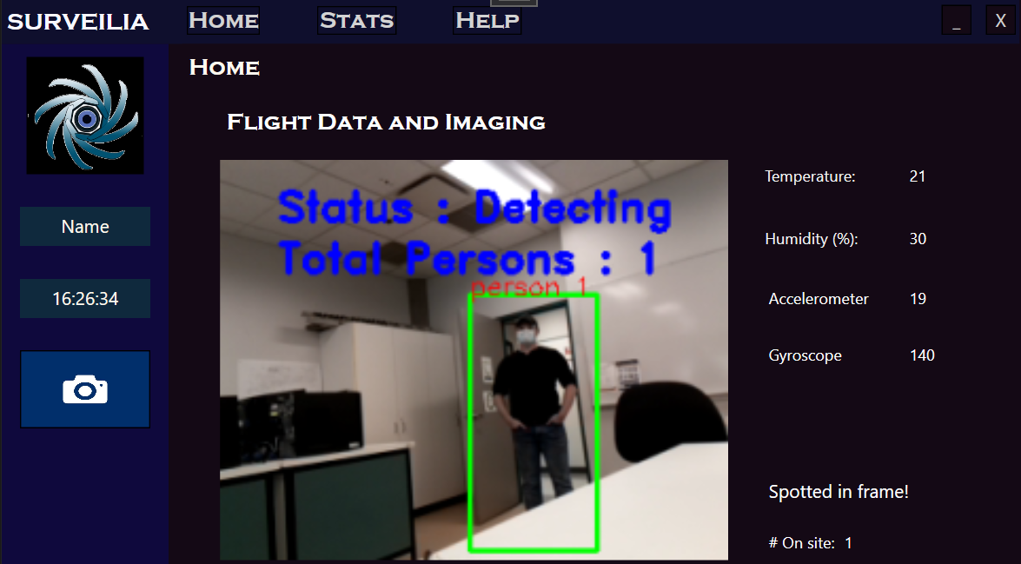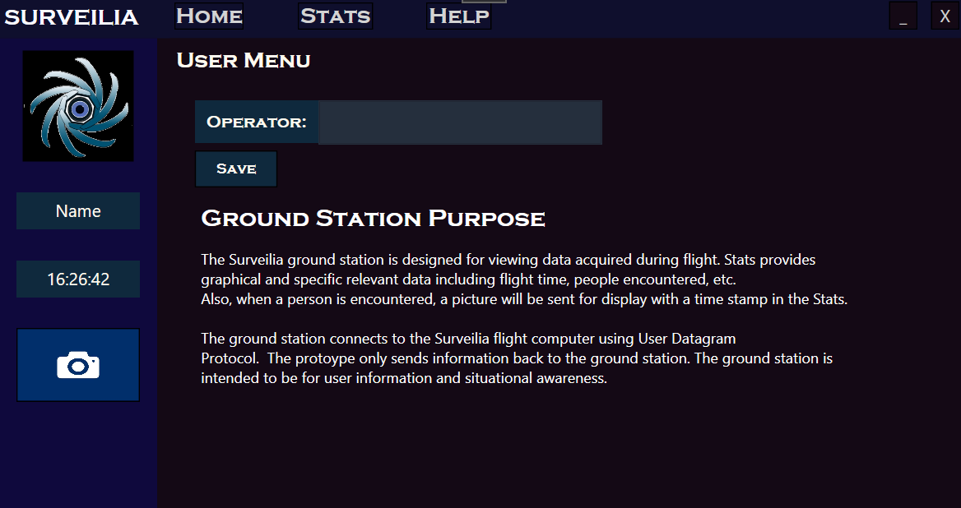

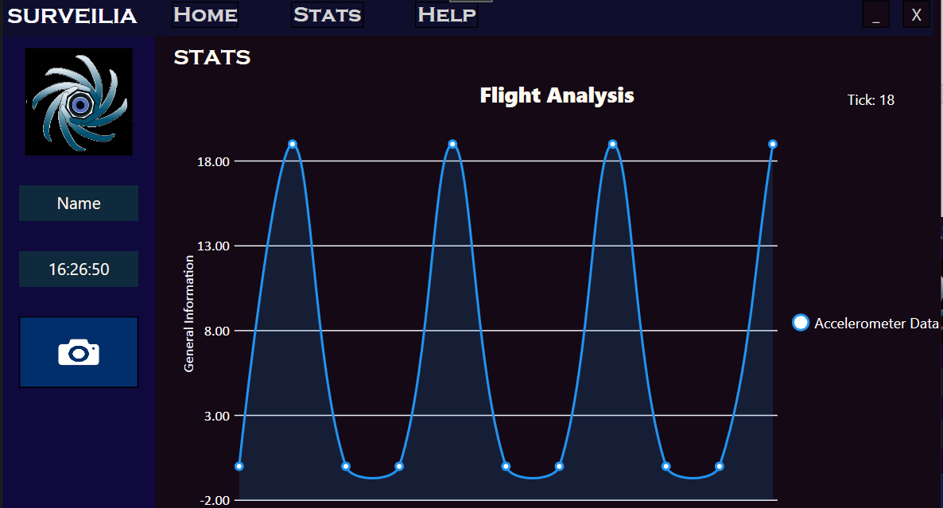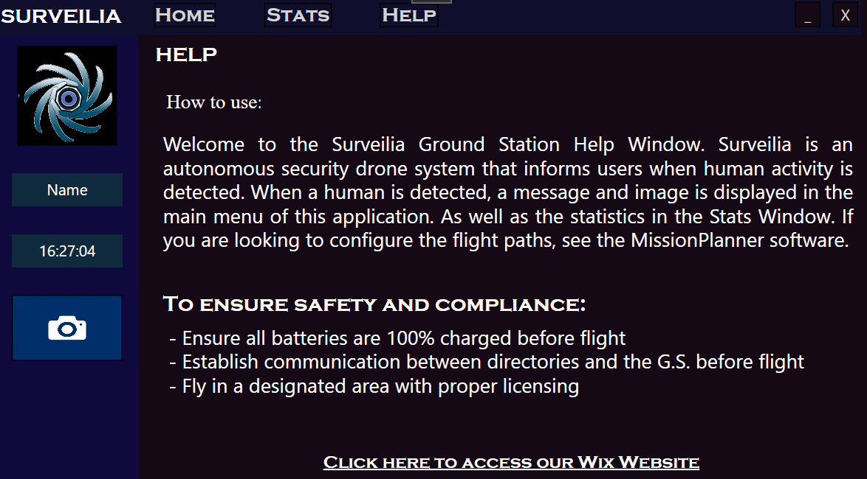

Figure 4 Ground station windows: Fake data, however the imaging worked just as intended during the symposium

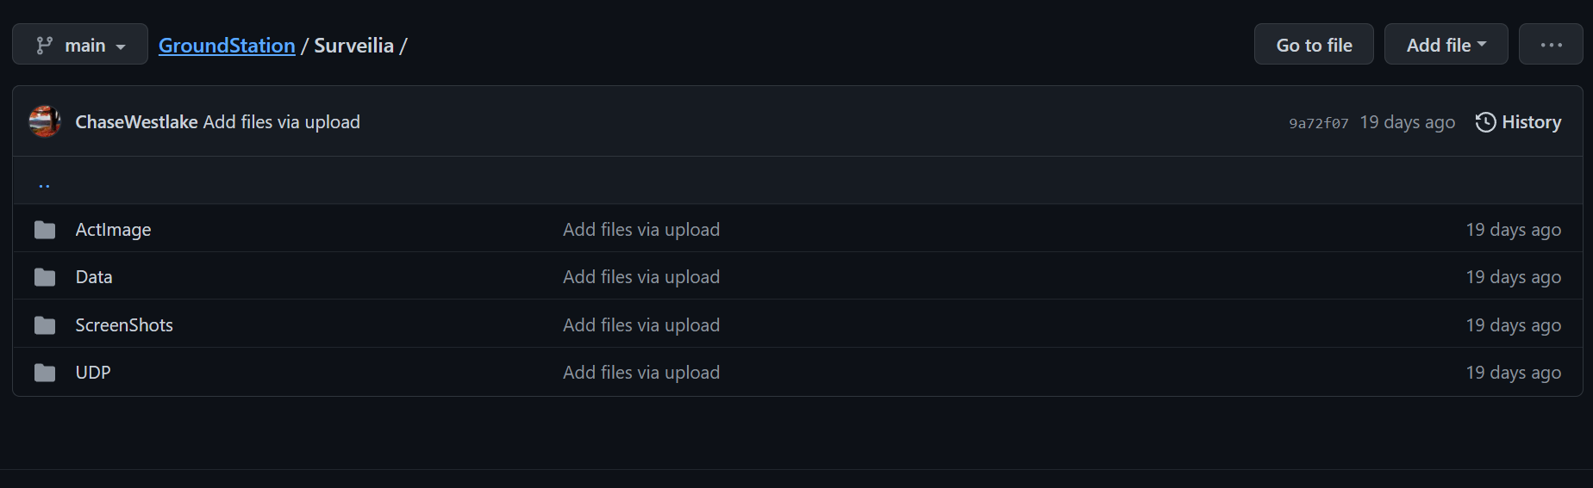

Figure 5 Section of ground station containing directories and scripts critical to the proper function and testing of ground station

**UDP & Packets**

The UDP and packet structure was used on both the host PC and the Pi. This was used to communicate data and images from the Pi to the ground station

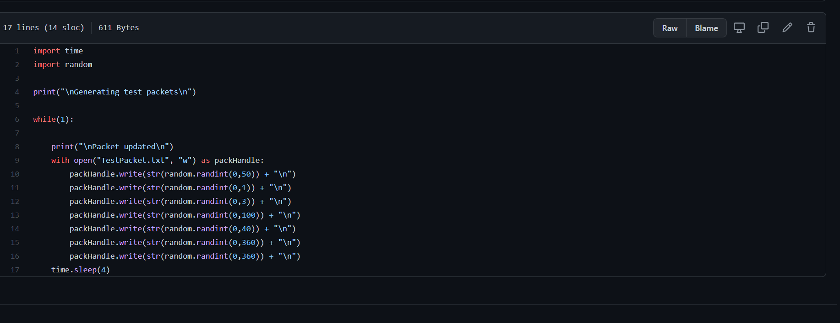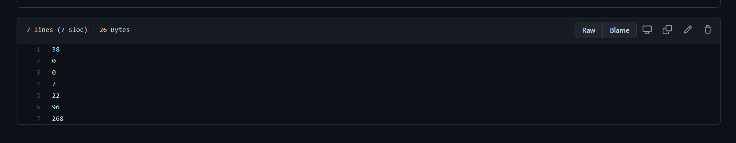

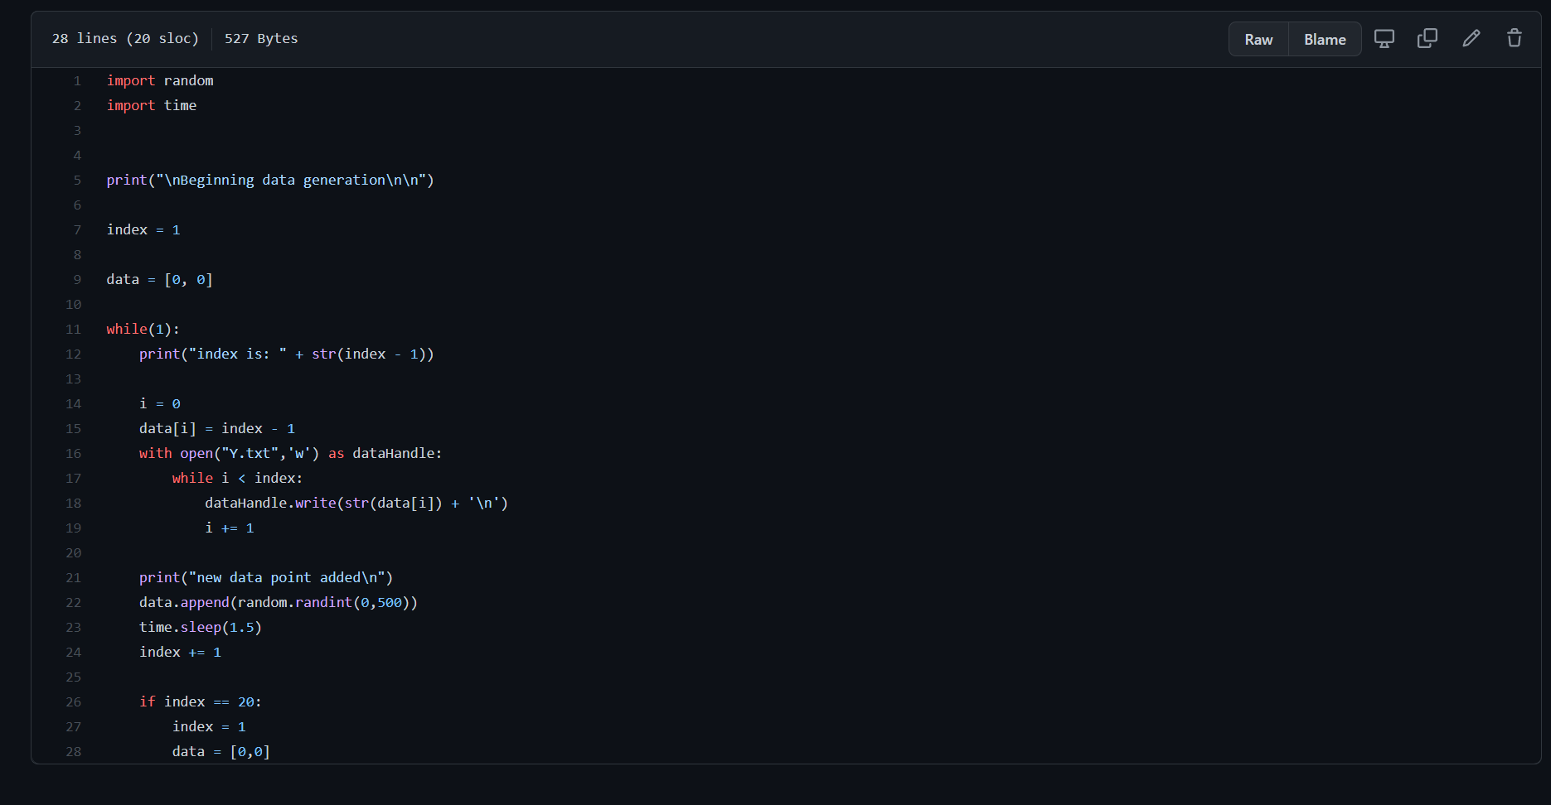

Figure 6 Testing files associated with verifying surveilia's packet design

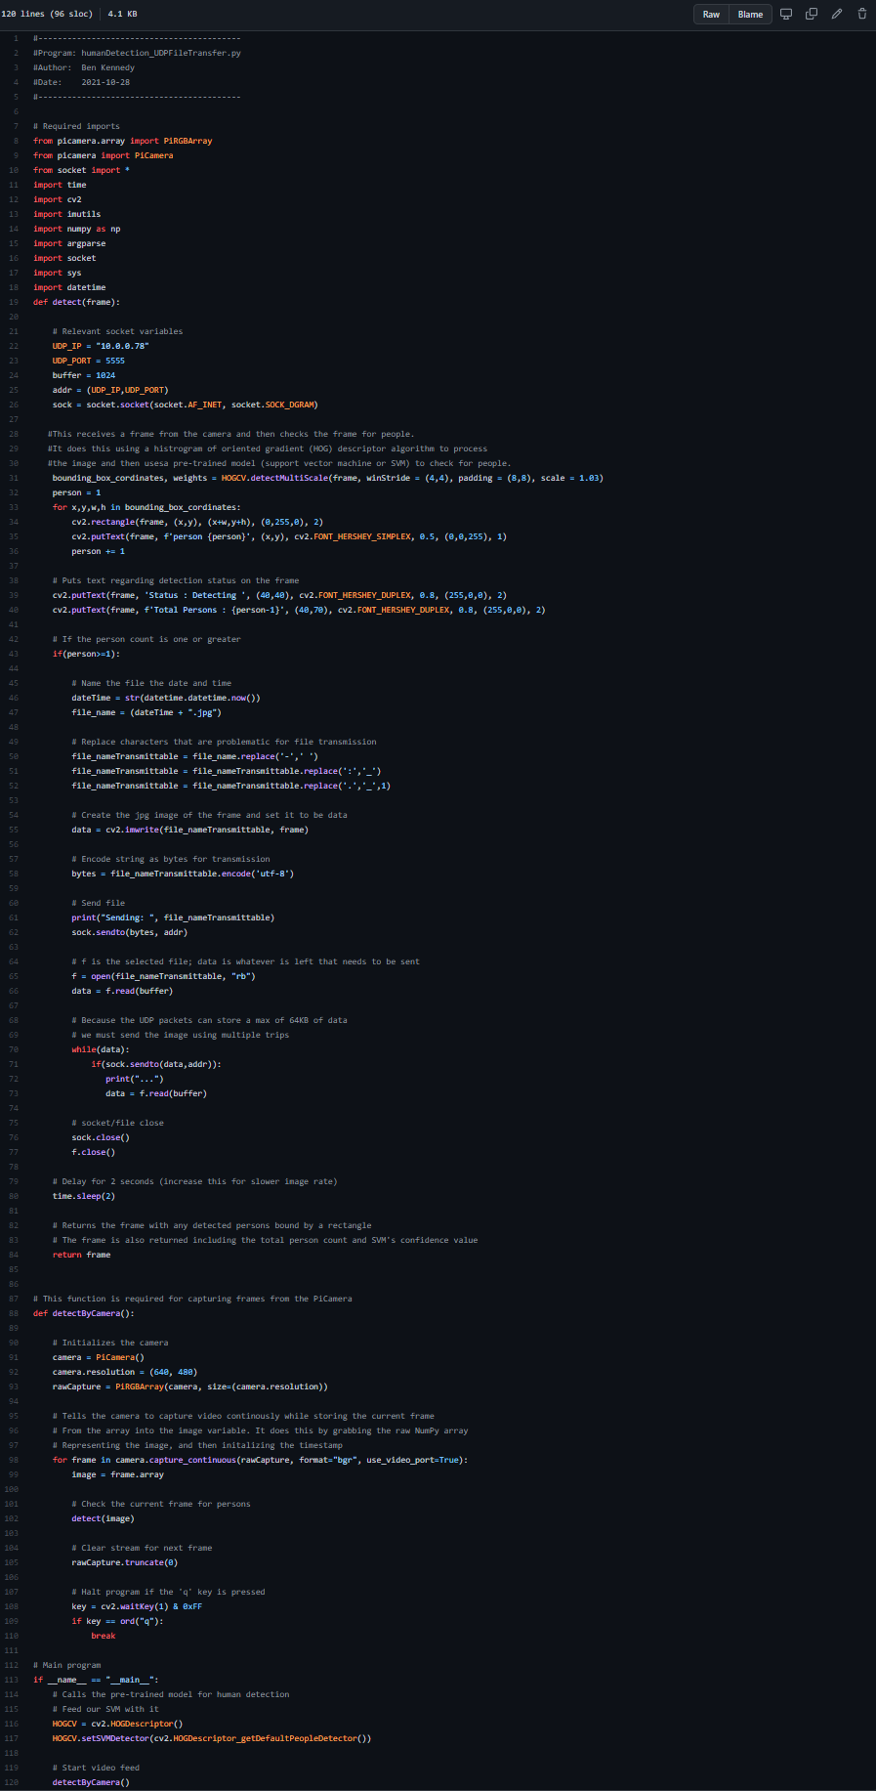

Figure 7 UDP Client code

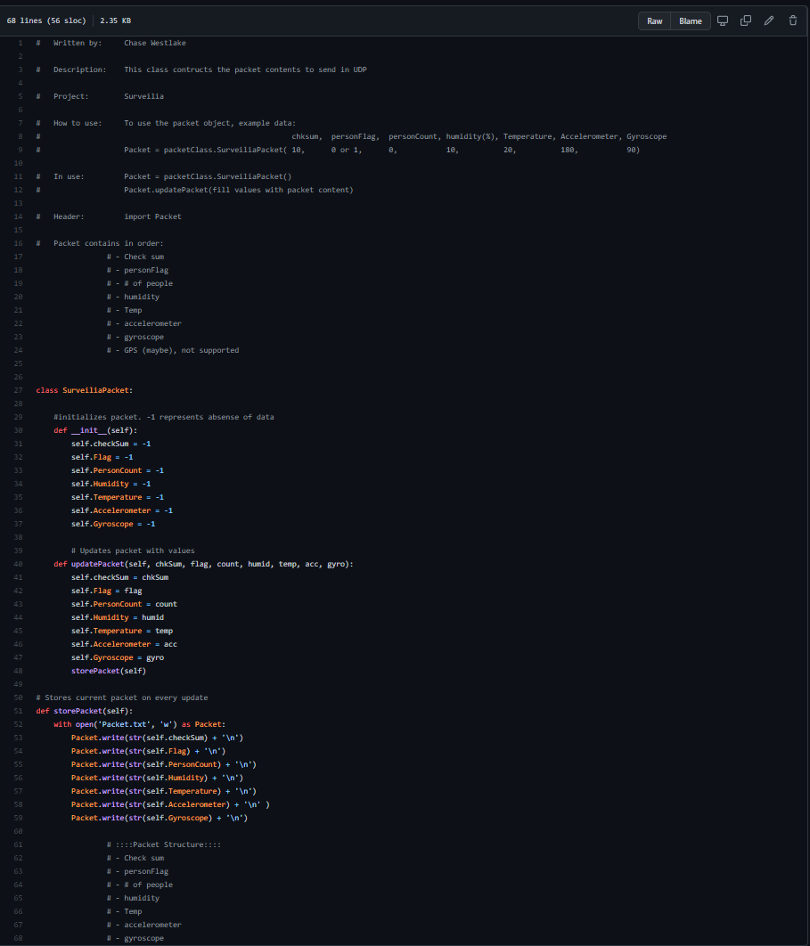

Figure 8 UDP packet structure

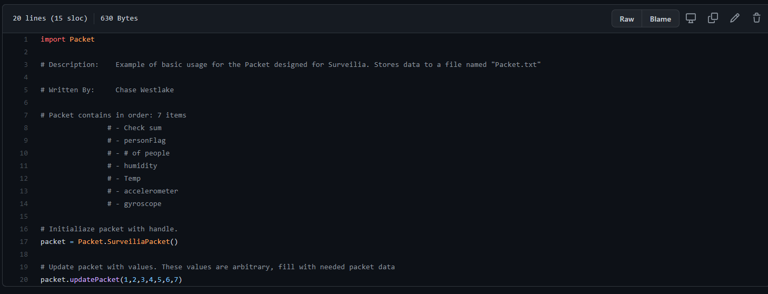

Figure 9 Example code for understanding the Packet structure

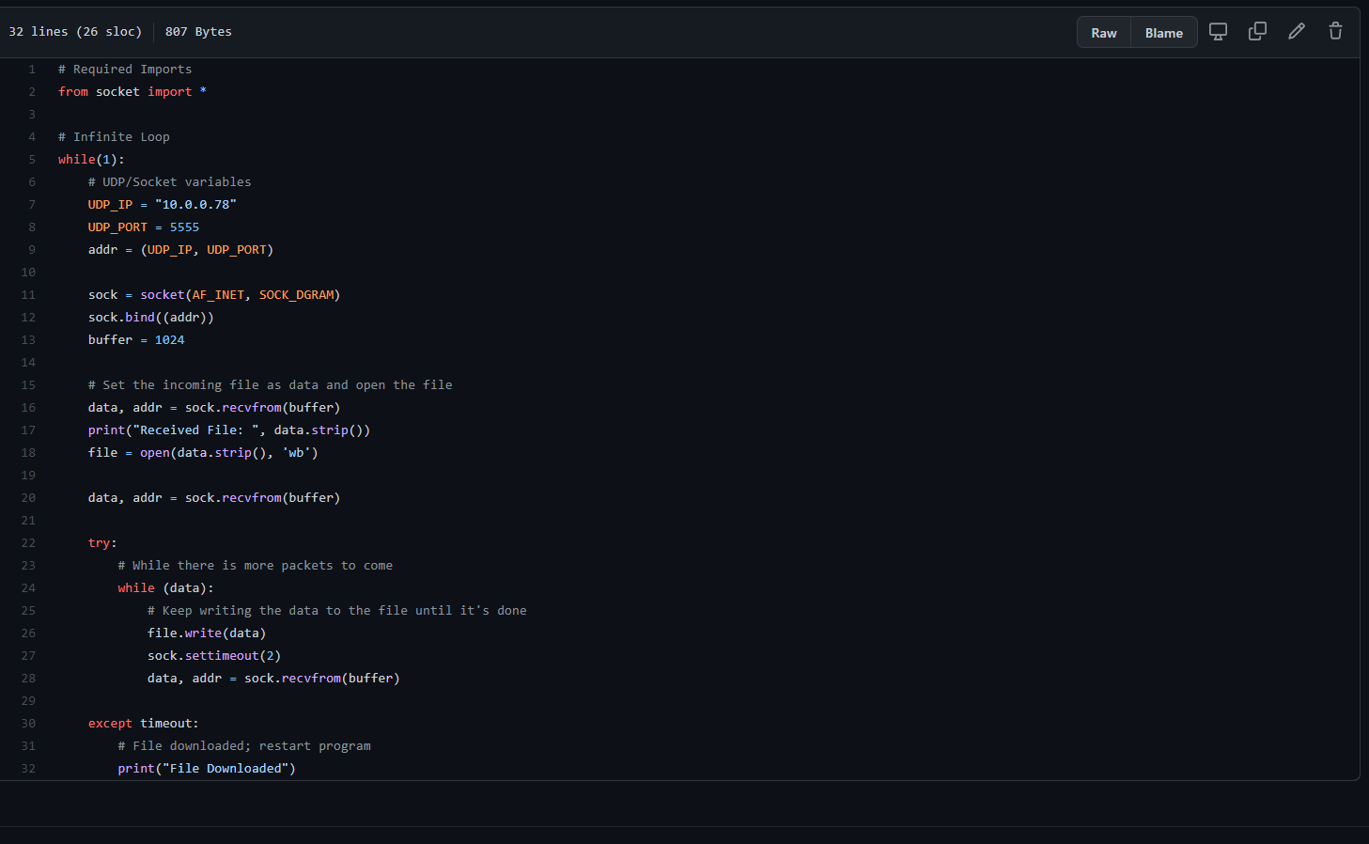

Figure 10 UDP Server code

**Raspberry Pi**

This section involves some of the scripting involved in The Pi Zero.

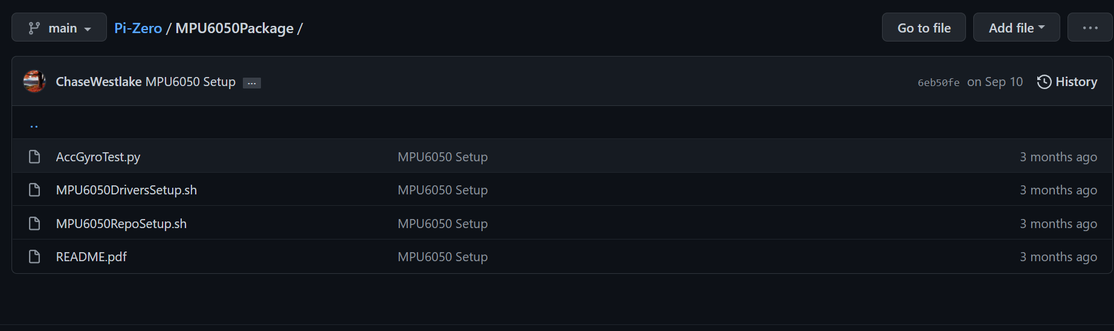

Figure 11 Packages designed to setup and test the acc and gyro for the Pi

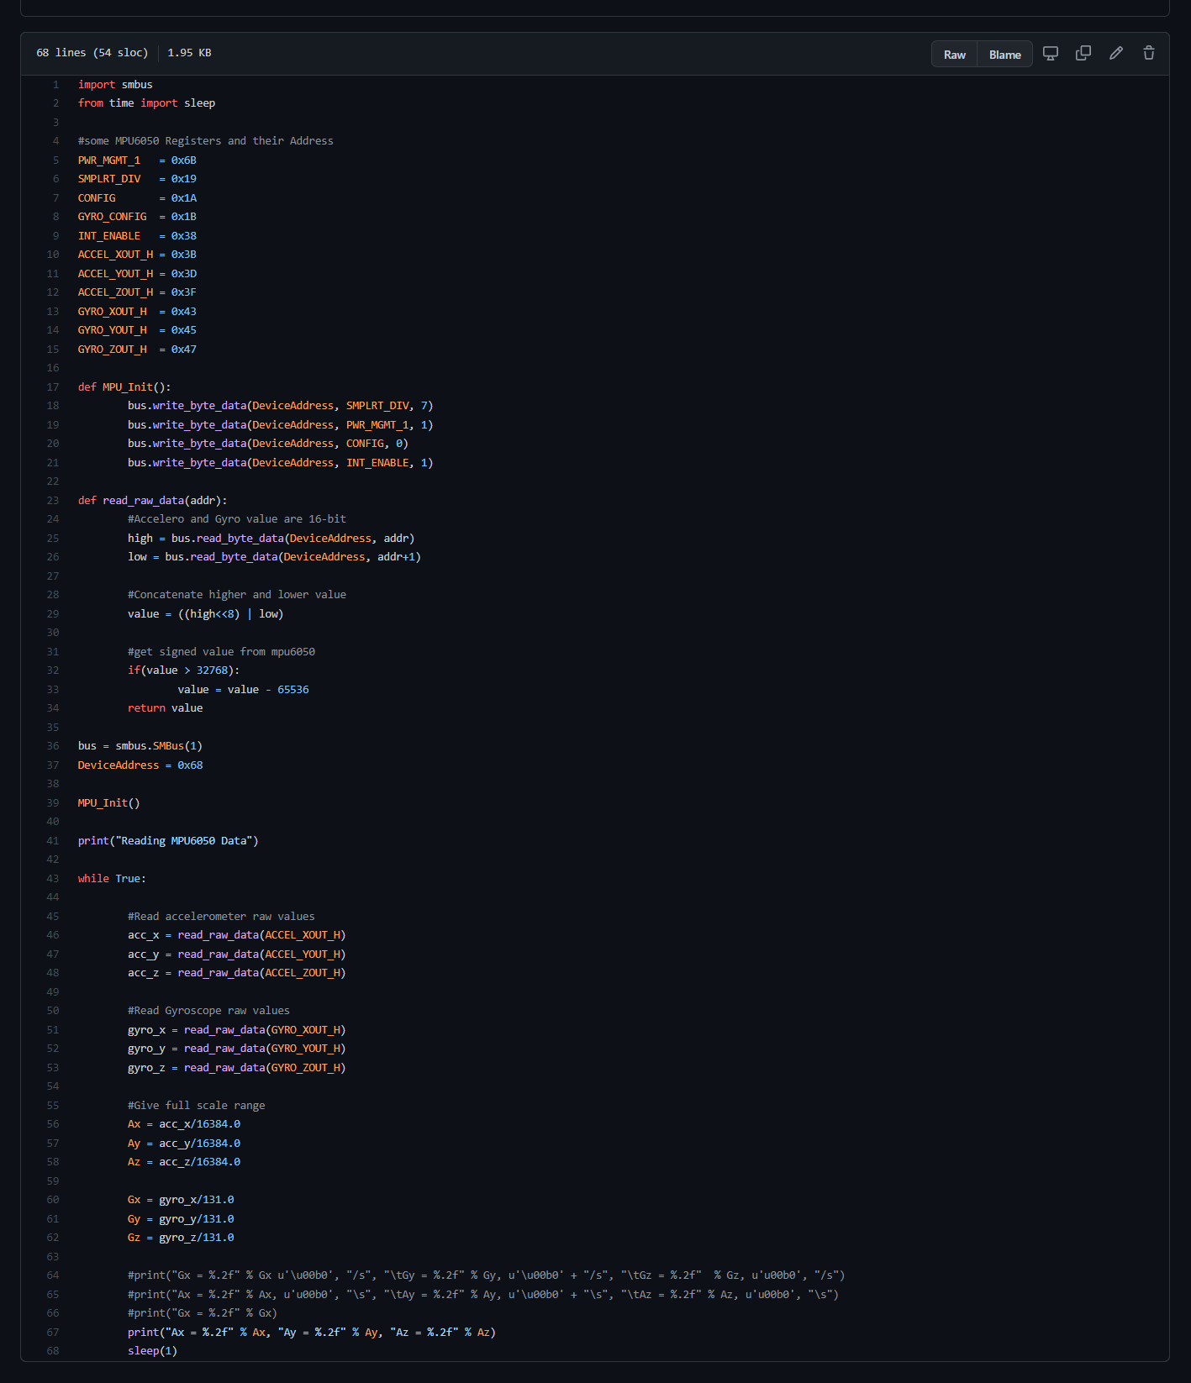

Figure 12 Acc & Gyro code

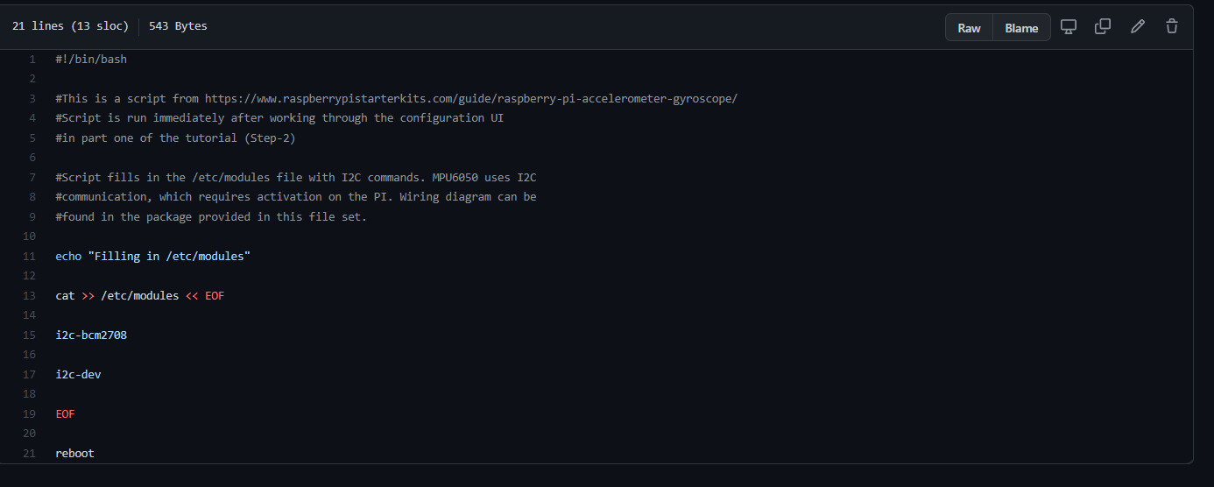

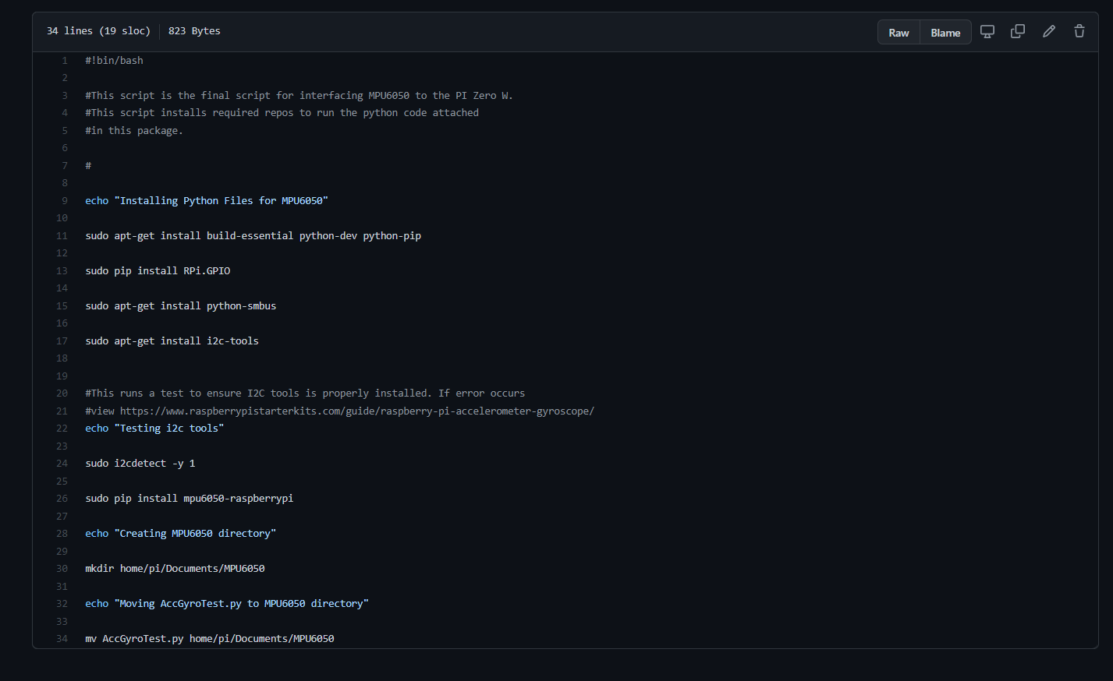

Figure 13 Scripts to install packages quickly on Pi

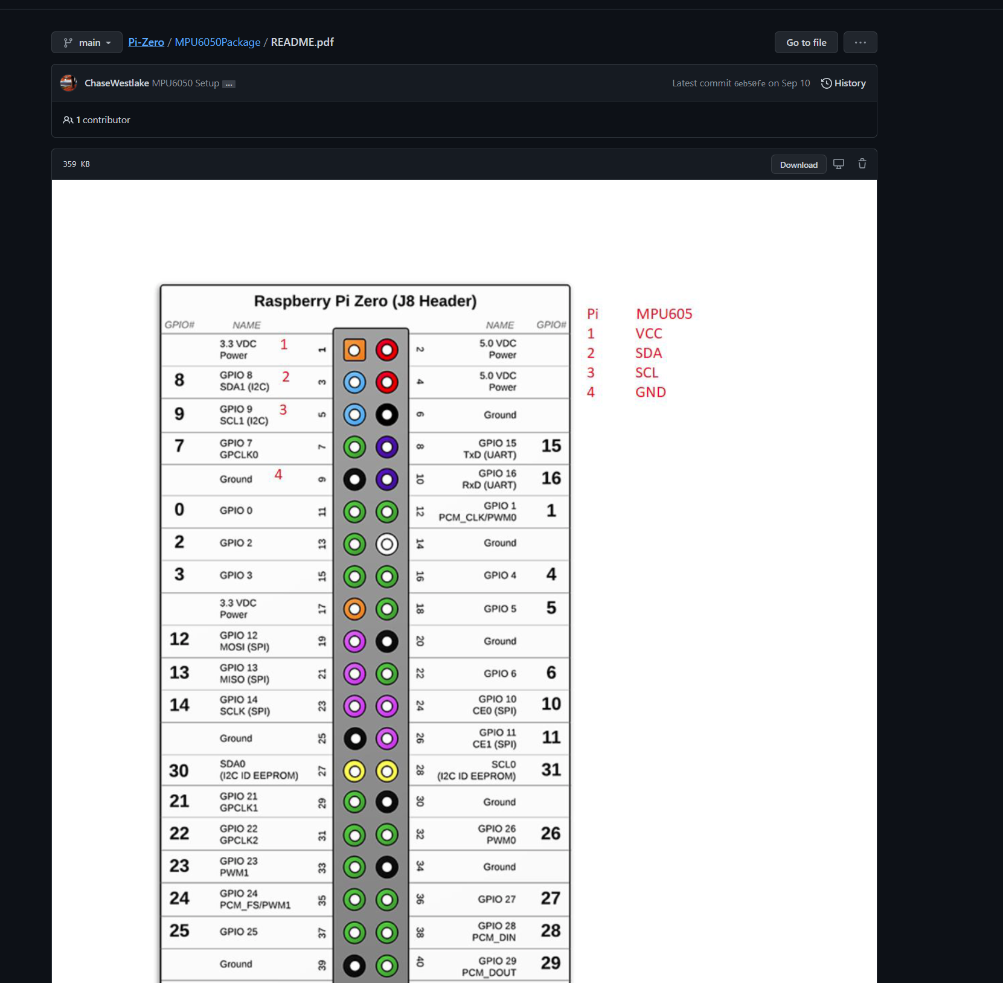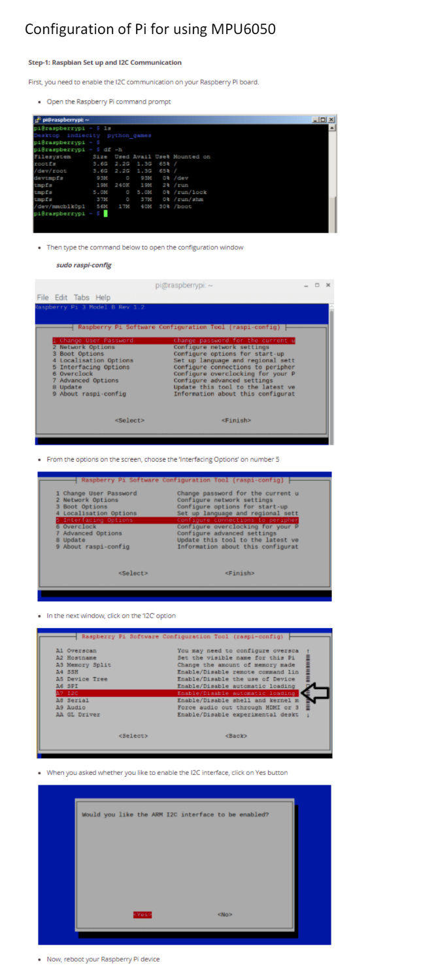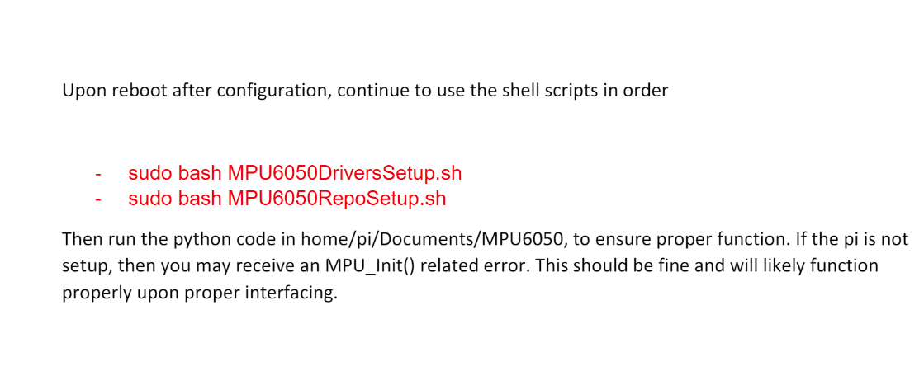

Figure 14 Package for quickly implementing packages

**PCB & Schematics**

The PCB and schematic for the Pi Zero Daughter board, and the Schematic for the CM4.

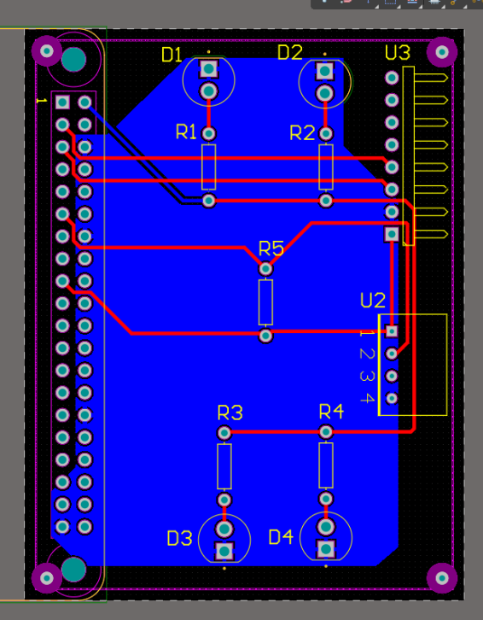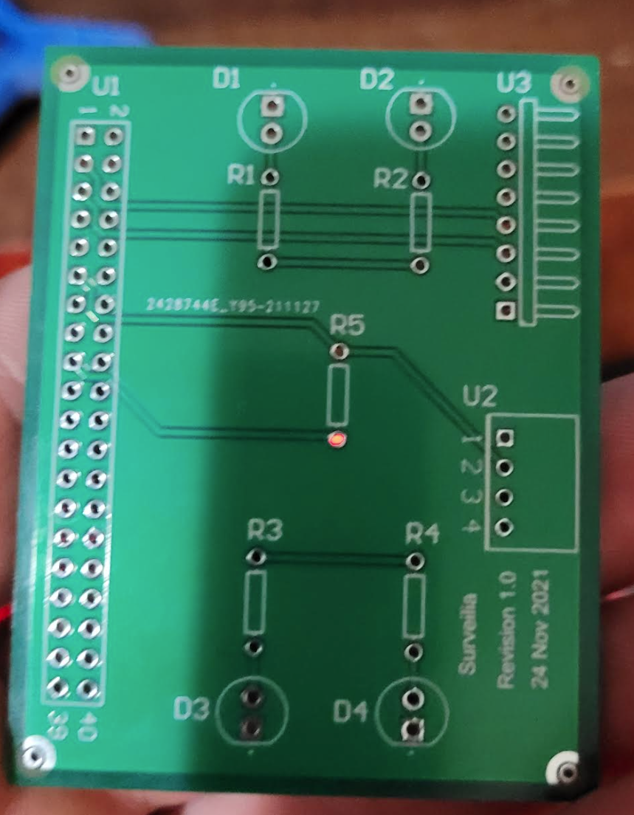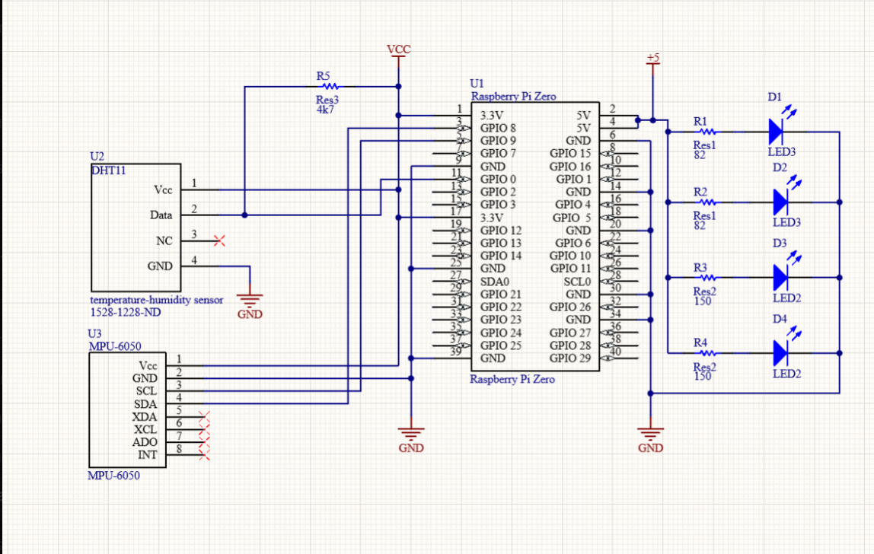

Figure 15 Pi zero daughter board & design

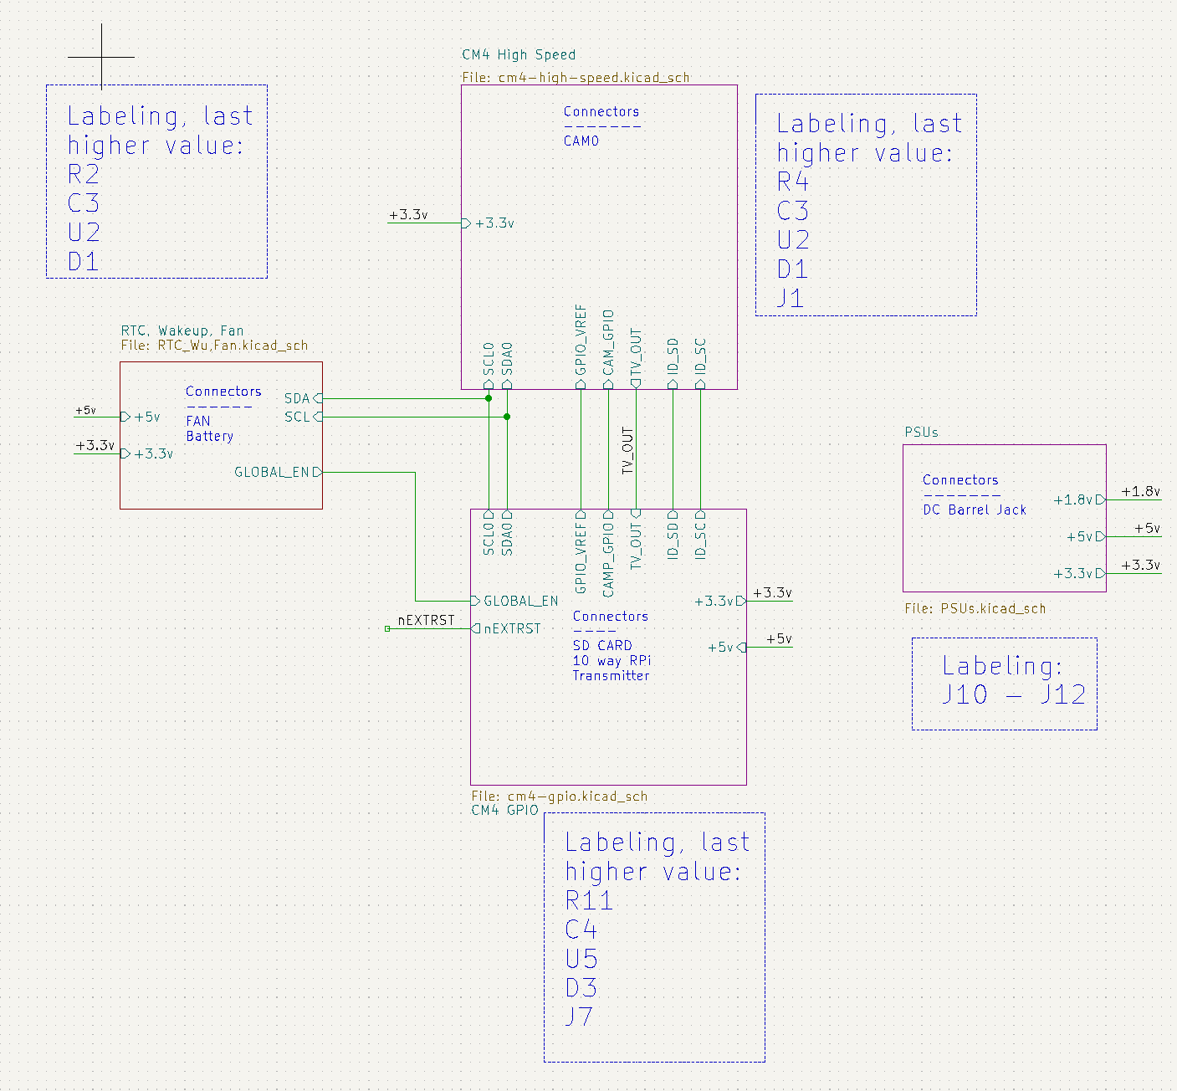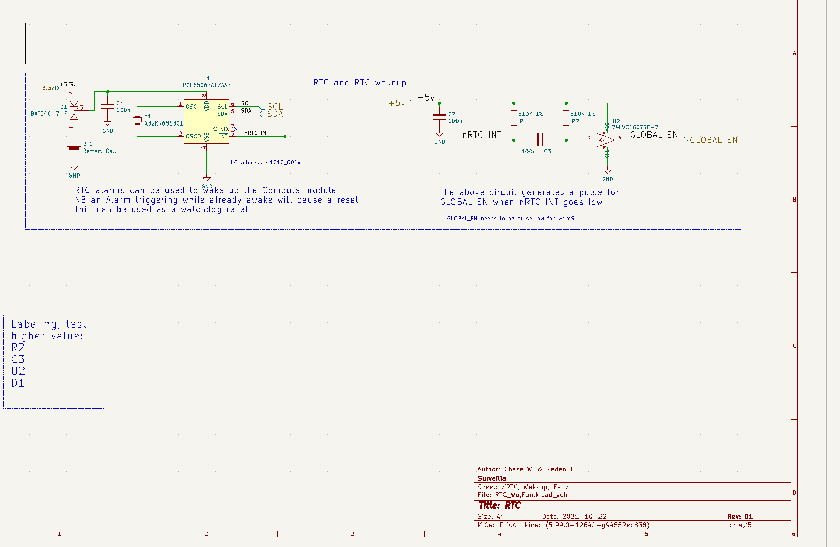

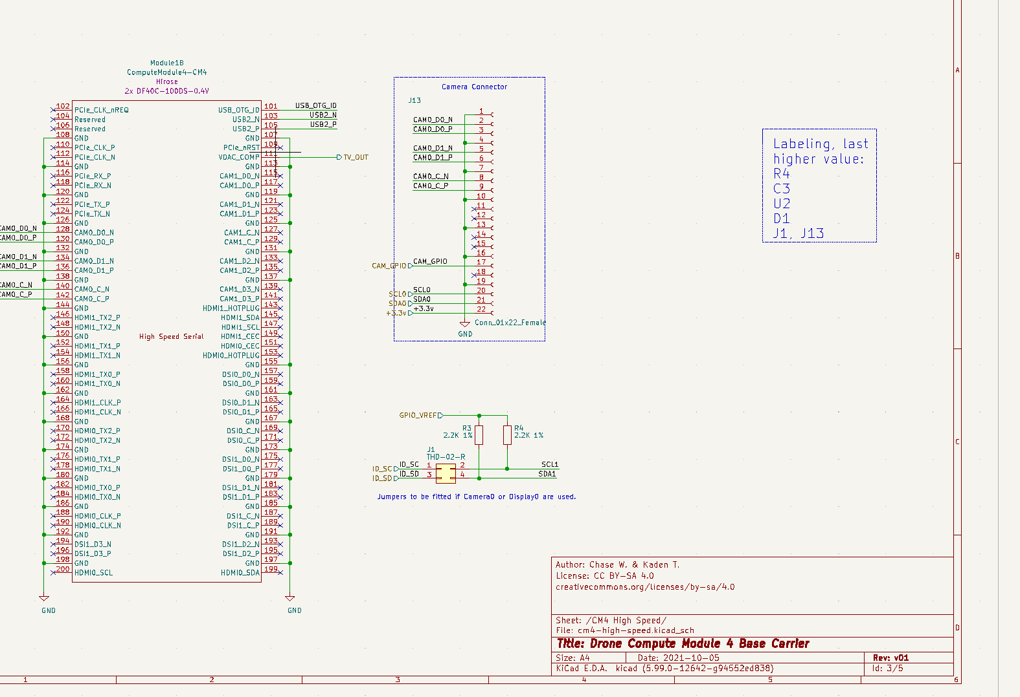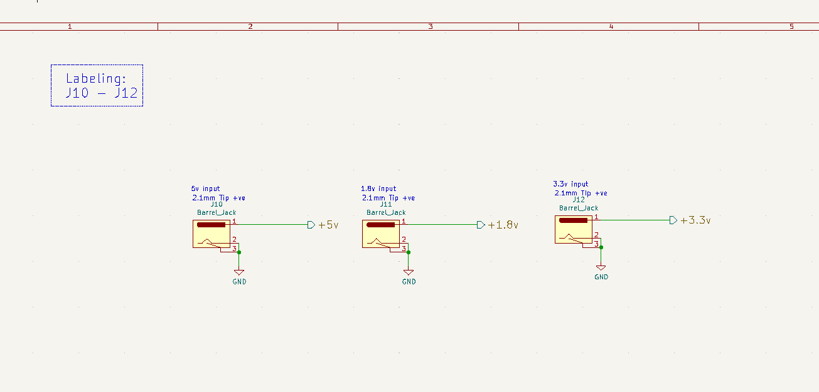

Figure 16 CM4 schematics. Please note, a lot of components were removed to try to limit parts which could not be found. This is the point we ended development

**Drone Body**

For drone body designs, please see [Surveilia/DroneBody: CAD for drone, built in Fusion 360 (github.com)](https://github.com/Surveilia/DroneBody), There are too many files to post all

**Flight:** [Surveilia - YouTube](https://www.youtube.com/channel/UCd5c4RO0jNjfYsUa9QAaFLg)

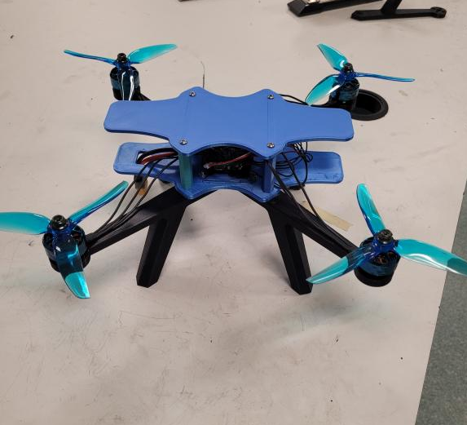

Figure 17 Drone built

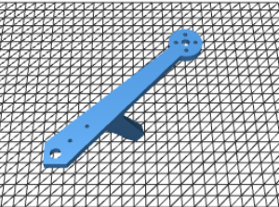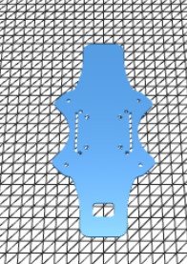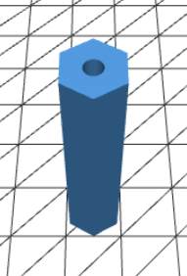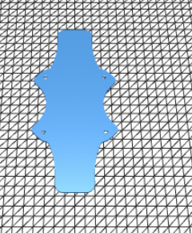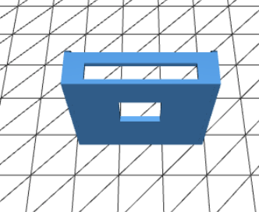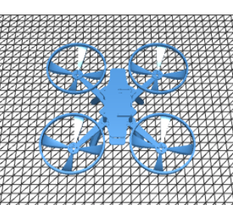

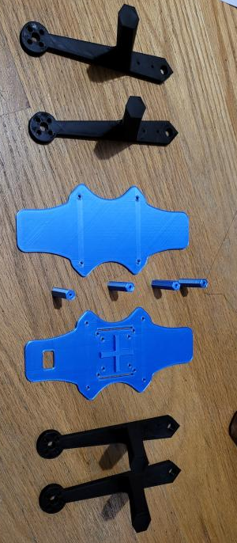

Figure 18 Chase & Kaden's printers used for printing. PETG is black, PLA is blue

**Human Recognition**

Human recognition was successful on the symposium day, and displayed perfectly on the ground station. Below are images from the Pi in OpenCV

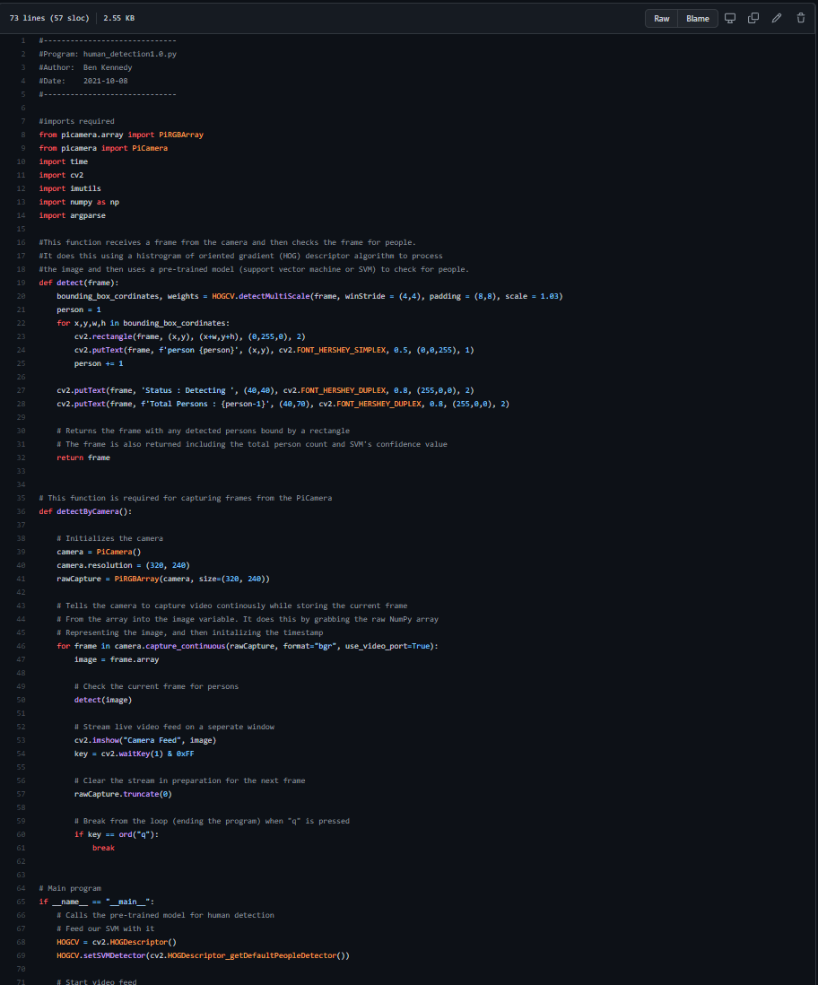

Figure 19 Human Recognition Code

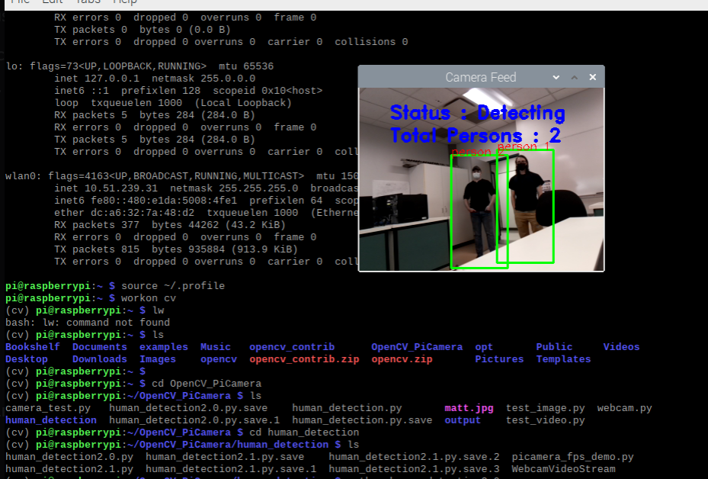

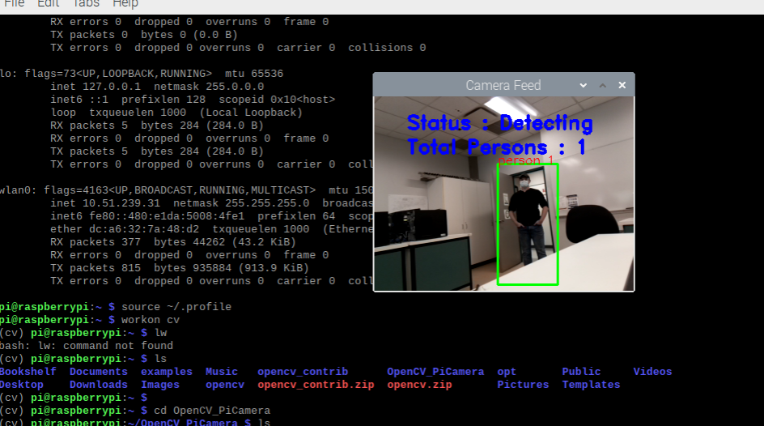

Figure 20 Human Recogntion recognizing people

**Beta Flight & Mission Planner**

Documentation is limited in Beta Flight & Mission planner.

However, information on our process can be viewed in the User manual contained in Documentation on Github.

BetaFlight took a fair bit of trouble shooting, but we achieved multiple successful flights and learned from all of the failures. We have positive control of the drone, as can be seen [Surveilia - YouTube](https://www.youtube.com/channel/UCd5c4RO0jNjfYsUa9QAaFLg)

Mission planner was incomplete, but we believe with a compass an autonomous flight could be achieved rapidly.